BIT 4107 – Mobile Application Development
ENHANCED PROFESSIONAL STUDENT LOGBOOK
Student Name: _YUSUF ANEMBA
Admission Number: _BIT/2020/90745
School/Faculty: _COMPUTING AND INFORMATICS
Programme: _INFORMATION TECHNOLOGY
Academic Year: ___4TH
Semester: _II_
Lecturer: _MR. NYORO_
Phone Number: _0759180663

Table of Contents
Instructions 3
Week 1: Introduction to Mobile Application Development 4
Practical Activities Undertaken 4
Tools/Software Used 4
Personal Reflection 4
Week 2: Mobile Development Environment 6
Week 3: User Interface Design 6
Same as week 1 6
Week 4: Event Handling and User Interaction 7
Same as week 1 7
Week 5: Data Management 7
Same as week 1 7
Week 6: Networking and APIs 8
Same as week 1 8
Week 7: Application Architecture 9
Same as week 1 9
Week 8: Project Planning 10
Week 9: Device Features and Sensors 11
Same as week 1 11
Week 10: Notifications and Background Services 12
Same as week 1 12
Week 11: Mobile Security 13
Same as week 1 13
Week 12: Testing and Debugging 13
Same as week 1 13
Week 13: Application Deployment 13
Same as week 1 13
Week 14: Final Project Presentation 13
Same as week 1 13
Semester Project Tracking 14
Project Title 14
Project Objectives 14
Project Requirements 14
Development Milestones 14
Testing Results 14
Lessons Learned 14
Future Improvements 14
End of Semester Reflection 15
Summary of Skills Acquired 15
Most Interesting Topic 15
Major Challenges Faced 15
How Challenges Were Overcome 15
Professional Growth Achieved 15
Overall Course Experience 15
Final Approval 15

Instructions
This logbook is used to document weekly learning activities, practical exercises, skills acquired, challenges encountered, solutions applied, and reflections. Students should complete all sections every week.
Each week to follow remarks in week 1 section.

Autogenerated Table of content

Week 1: Introduction to Mobile Application Development

- Toolchain Installation: Confirmed configuration parameters for Visual Studio Code, Node.js packages, and mobile rendering targets.
- Project Directory Setup: Formed the root workspace and structural source files using the Expo terminal CLI.
- Environment Troubleshooting: Debugged path context boundaries within the Windows command terminal to safely run active packaging commands inside the localized workspace.

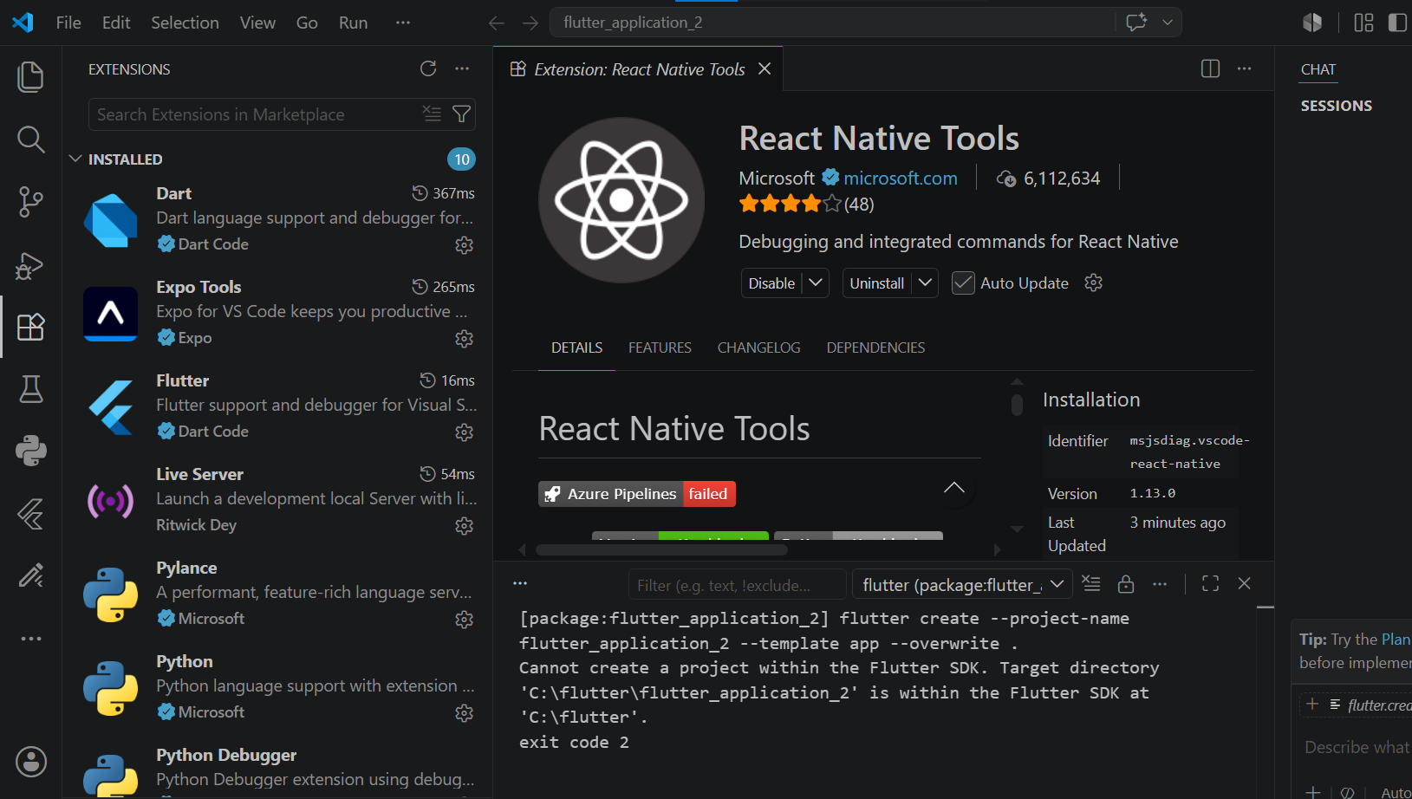Figure 1.1 Successful installation of extensions in vs code

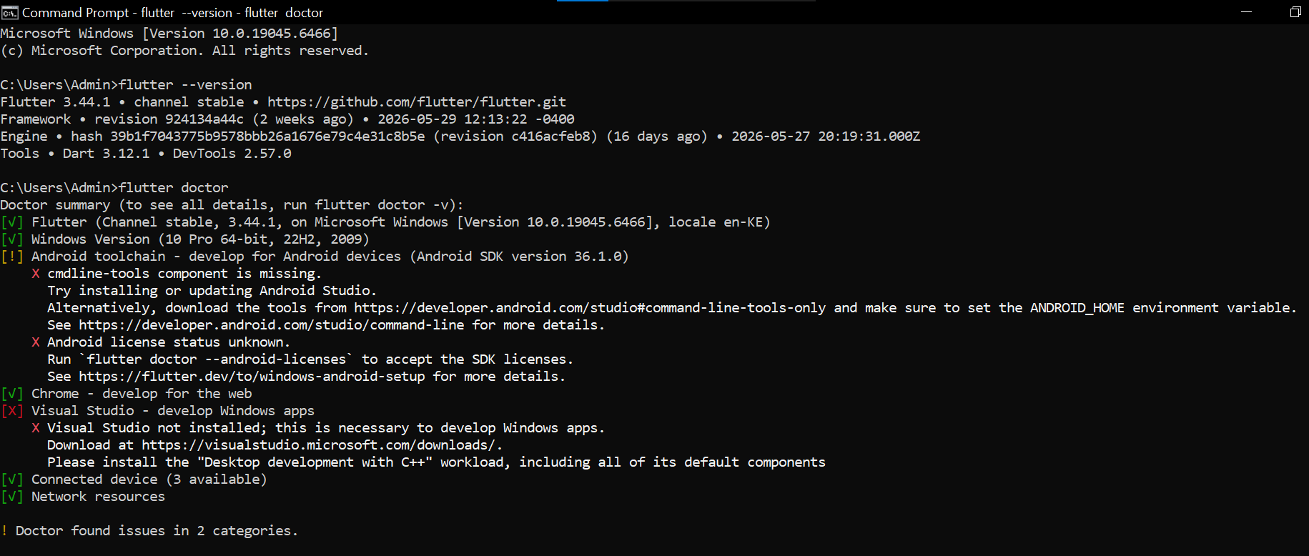
Figure 1.2 Running flutter doctor for the first time
I ran into several issues, one being I had not installed the SDK manager and the other one I had not downloaded and set up the visual studio for windows apps development.

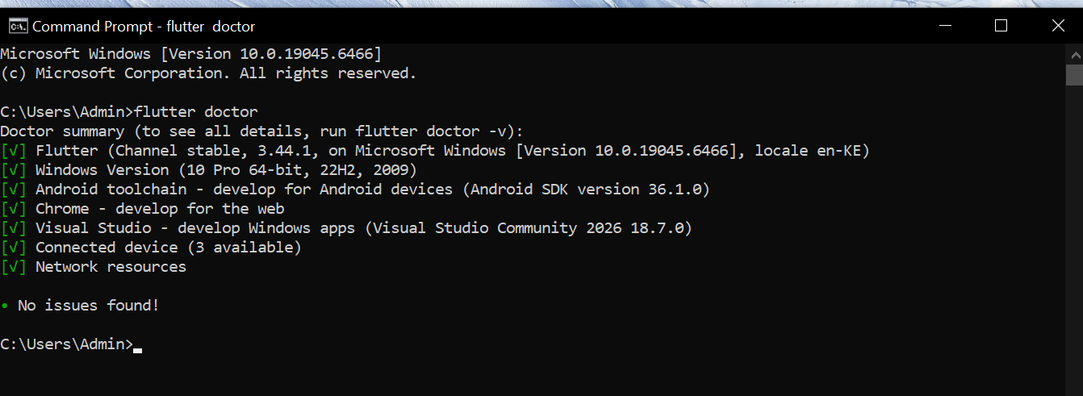
Figure 1.3 running flutter doctor successfully with no issues found.
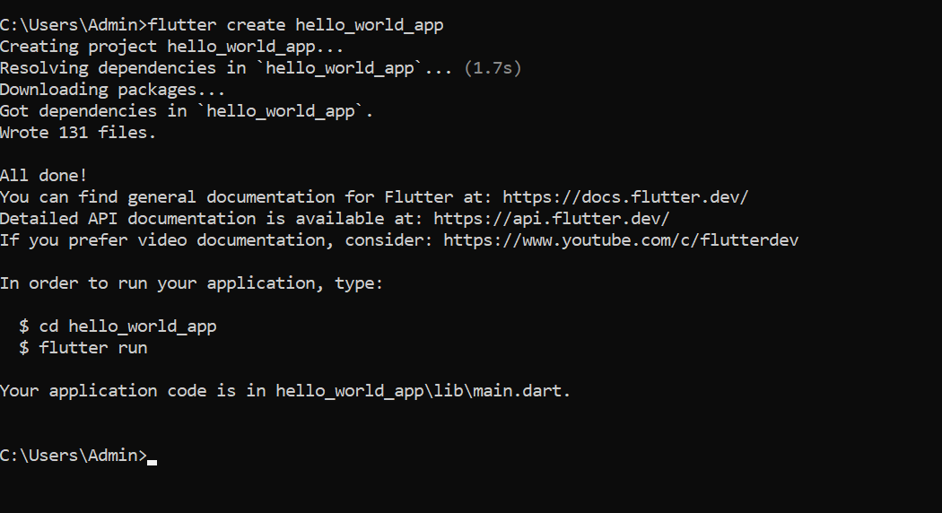
Figure 1.4 creating the hello world mobile app from the command prompt.

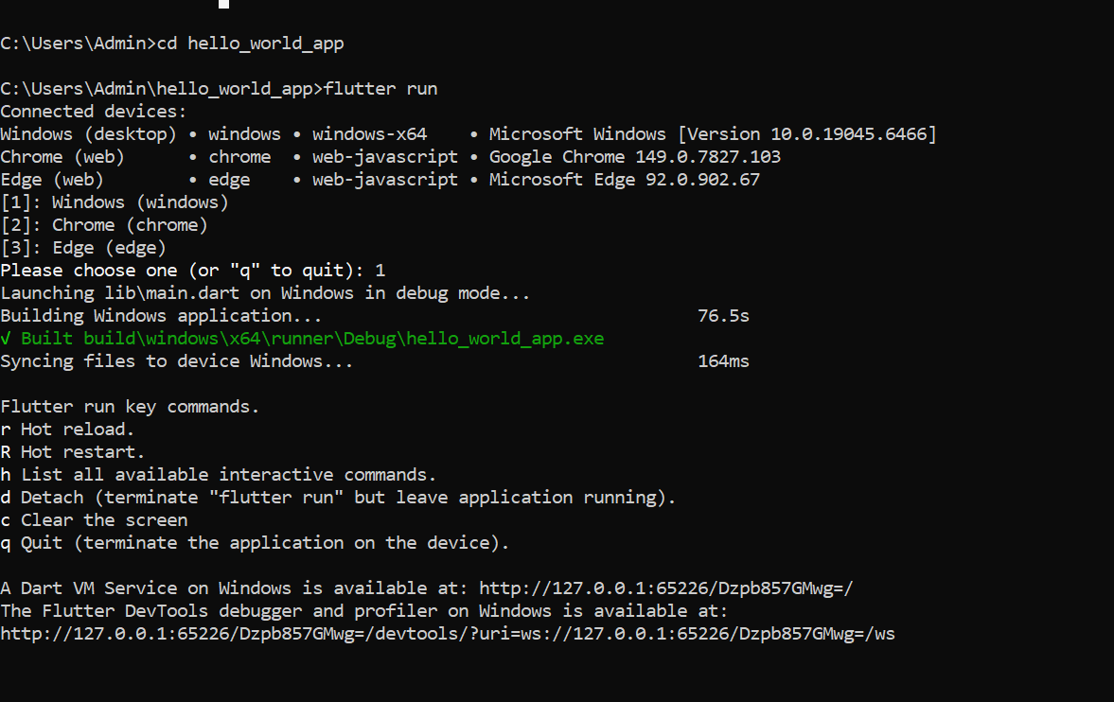
Figure 1.5 ran flutter to start creating the app

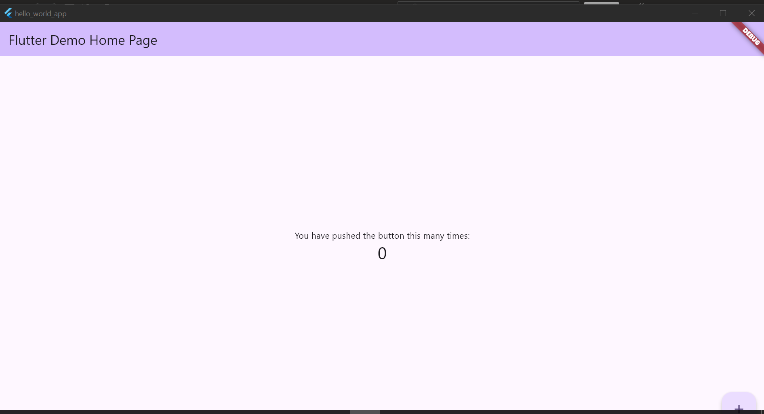
Figure 1.6 demo app created and running
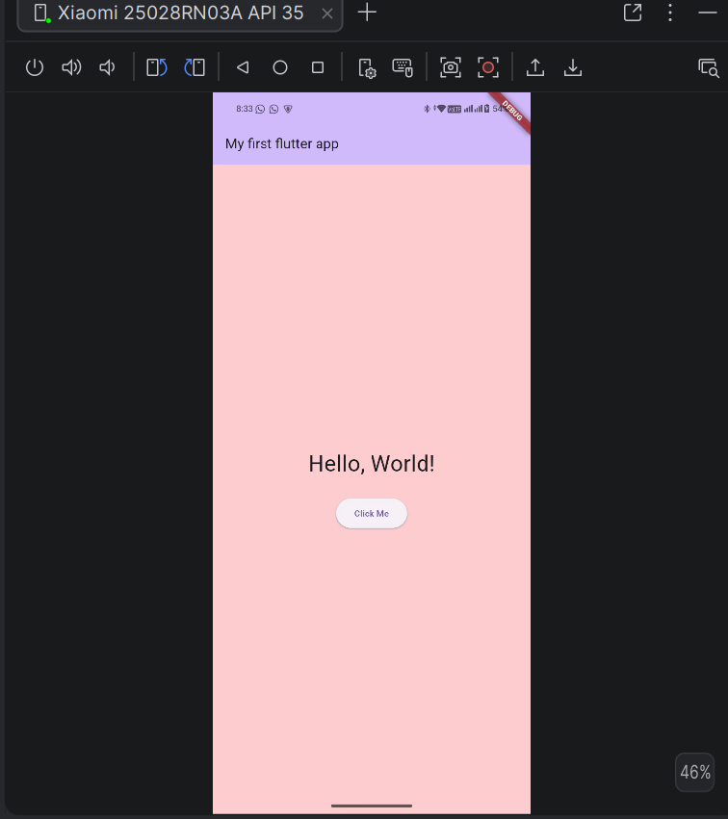
Figure 1.7 hello world mobile app
This is my first hello world app with a button.
Tools used
- Flutter
- Java JDK 17
- Andriod studio
- Dart
- CMD

Week 2: Mobile Development Environment
Same as week 1

Week 3: User Interface Design

Same as week 1

Week 4: Event Handling and User Interaction

Same as week 1

Week 5: Data Management

Same as week 1

Week 6: Networking and APIs

Same as week 1

Week 7: Application Architecture

Same as week 1

Week 8: Project Planning

Week 9: Device Features and Sensors

Same as week 1

Week 10: Notifications and Background Services

Same as week 1

Week 11: Mobile Security

Same as week 1

Week 12: Testing and Debugging

Same as week 1

Week 13: Application Deployment

Same as week 1

Week 14: Final Project Presentation

Same as week 1

Semester Project Tracking

Project Title

Project Objectives

Project Requirements

Development Milestones

Testing Results

Lessons Learned

Future Improvements

End of Semester Reflection

Summary of Skills Acquired

Most Interesting Topic

Major Challenges Faced

How Challenges Were Overcome

Professional Growth Achieved

Overall Course Experience

Final Approval
Student Name: __________________________
Student Signature: ______________________
Date: _________________________________
Lecturer Name: _________________________
Lecturer Remarks: _____________________
Date: _________________________________

